**High level overview of MediaFlow 2.0 processes and support**

MediaFlow 2.0, in this document, refers to the integrated use of:

* R25: Source of record for scheduling data
* Mediasite: Hardware appliances and online dashboard that records & hosts lecture media
* Capture Monitor: Online dashboard used for review of scheduled captures and daily QA
* MediaDropBox: Online tool for uploading presentations to link to scheduled lectures
* Lecture Media page: Pages created for each short-title, provides students access media

Safeties are a separate process and run independent of Mediaflow 2.0.

1. **Room scheduling with R25 (including last minute changes)**

Scheduling done via <http://med.stanford.edu/irt/edtech/classrooms.html>. Medscheduler enters data into R25, which is source of record.  
  
Any changes are ideally submitted via email to [medscheduler@stanford.edu](mailto:medscheduler@stanford.edu).

1. **Reviews of scheduled captures**  
   Daily sync-up review of upcoming capture schedule takes place each day at 2pm PST. Sync-up reports are archived at <https://stanfordmedicine.box.com/s/ypxm1am8g29o2qacb6k6>  
     
   Ad-hoc review of scheduled events by classroom space are available via <http://med.stanford.edu/irt-resources/classrooms/25livecalendar/web/index.html>

John reviews polling report late each afternoon to confirm polling success

1. **QA process**  
   EdTech employs two student workers to review any content captured via the LKSC system. Any captures are to be reviewed within 1-2 business days, with the primary focus on link verification, PHI scrub, use of microphone.  
     
   QA process done via [https://med-intranet.stanford.edu/mediaflow/#](https://med-intranet.stanford.edu/mediaflow/)
2. **MediaDropBox and Canvas integration and consumption of media by students and faculty**  
   Systems involved:

R25 > MediaDropbox to verify short title ID  
MediaDropbox > Canvas to check for matching short title ID  
R25 > Capture Monitor to reserve room resources  
Capture Monitor > Mediasite to schedule capture  
Mediasite executes capture  
Capture Monitor retrieves the links from Mediasite  
Capture Monitor publishes links to MediaDropbox

1. **Some numbers on usage (Jan. 2015 to current)**  
   Total usage: 34201 views on 3,392 captures with 11,470 hours of content. 1,449 unique users.

1. **General idea of the yearly schedule (busy times, etc)**  
   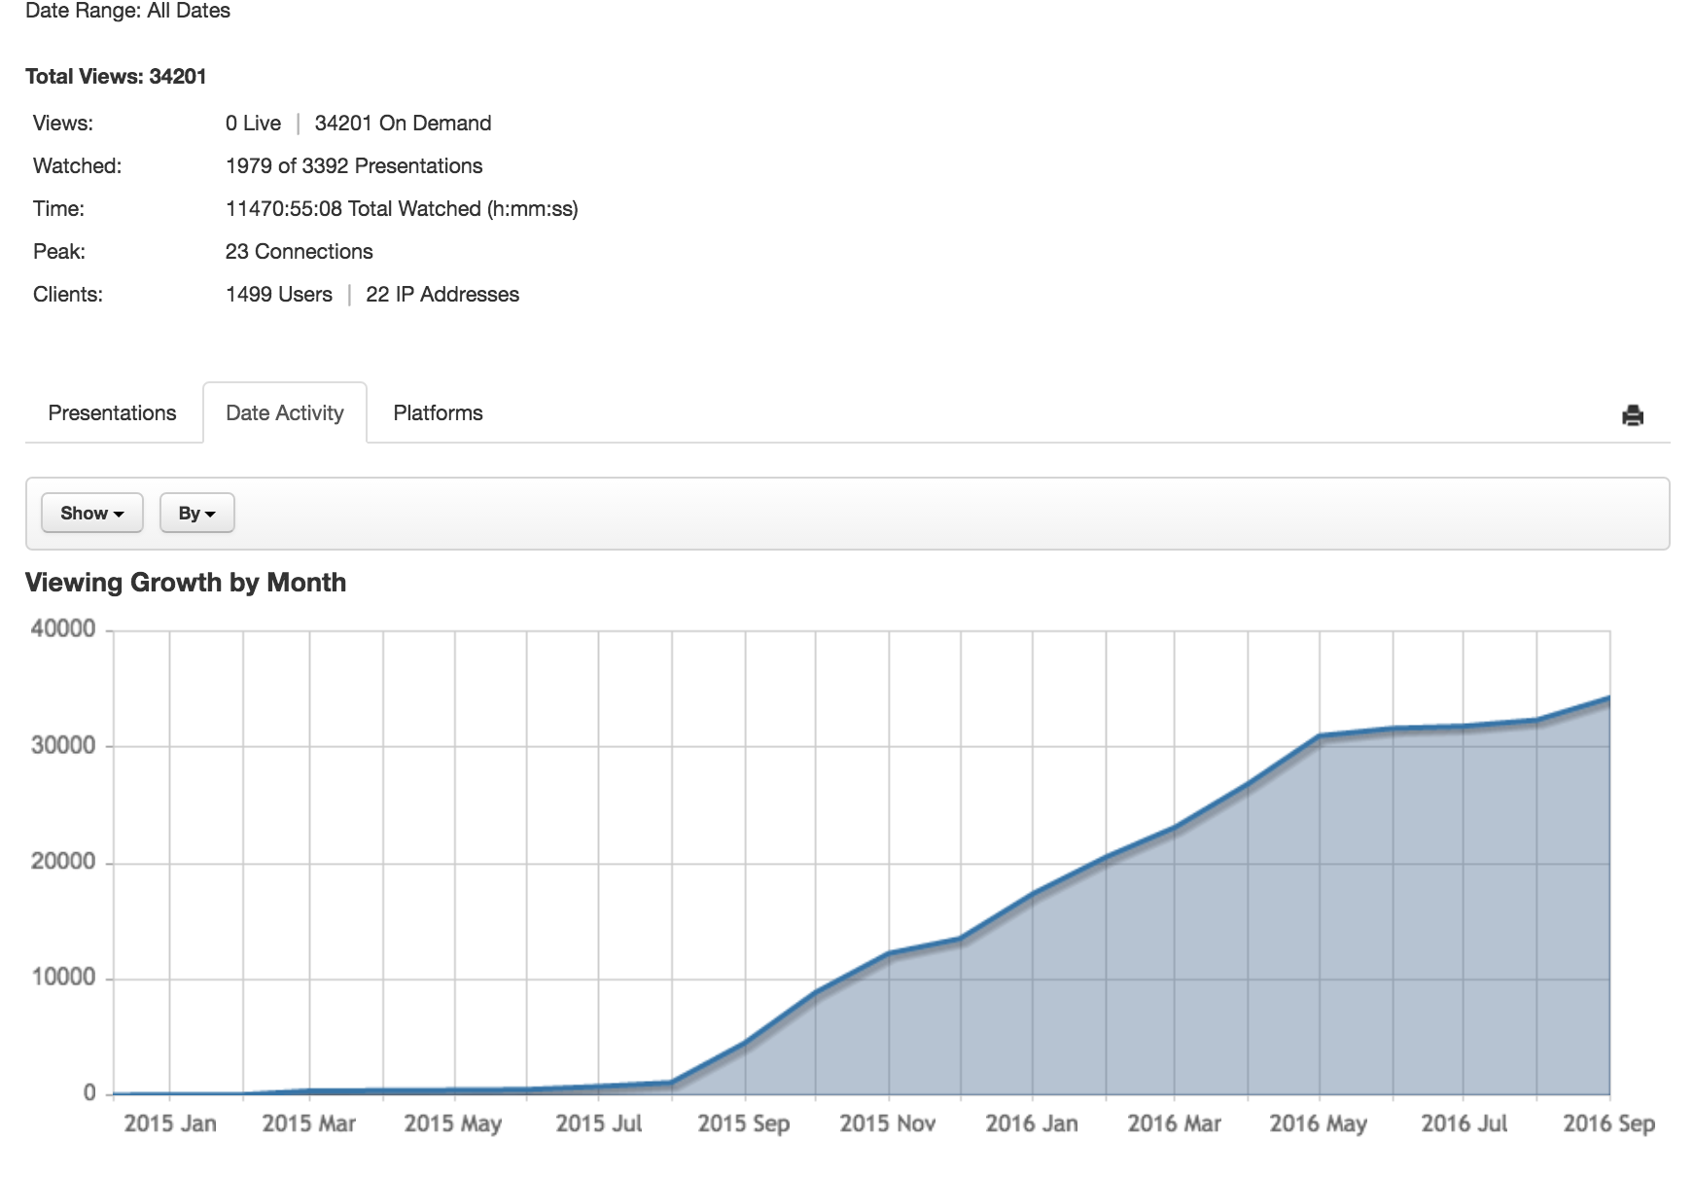
2. **Future plans (with mediasite, alternatives)**  
   To be discussed
3. **Safeties**  
   Info from John
4. **PHI handling and editing**  
   Ideally, notification is from faculty in advance and capture is held pre-recording.
5. **EdTech structure - main people they may interact with**

